HELLO!
- My name is Bethan and I will be your child’s new teacher for the academic year 2020-2021.
- I have been working at Mayfield School for the past 5 years.
- Our class name is W3.1 we will be at Mayfield School – Wheeler Street Site.
- To support your children we also have Tina, Baldev and Sandy.
- One of the teaching assistants will be your child’s keyworker

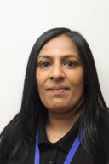
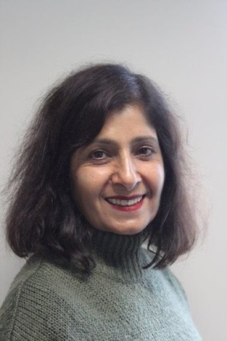

Tina Baldev Sandy

