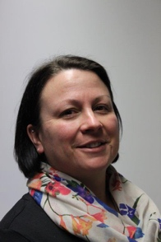
HELLO!
- My name is Fiona and I will be your child’s new teacher for the academic year 2020-2021.
- I have been working at Mayfield School for the past year.
- Our class name is Monkeys we will be at Mayfield School – Wheeler Street Site.
- To support your children we also have Pam, Dee and Sadie.
- One of the teaching assistants will be your child’s keyworker
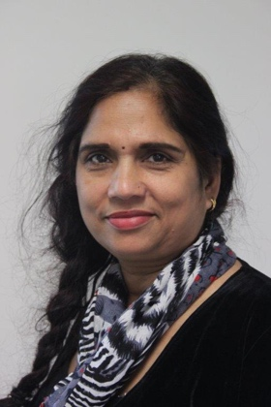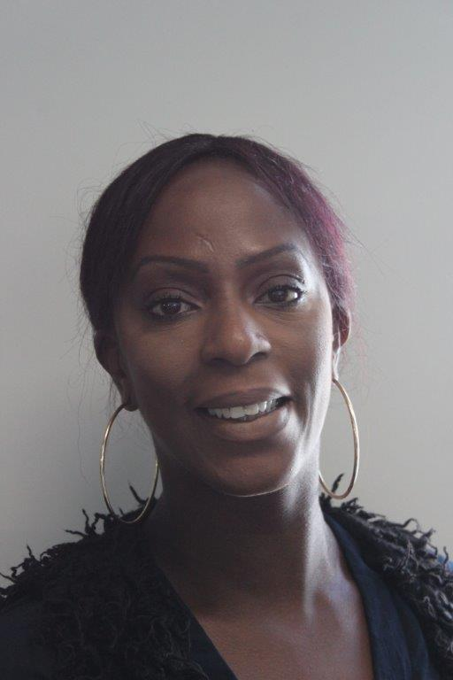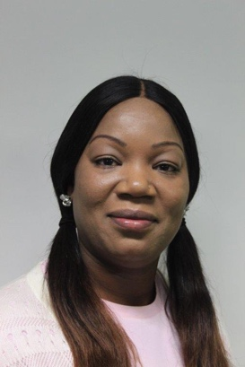

Pam Dee Sadie

