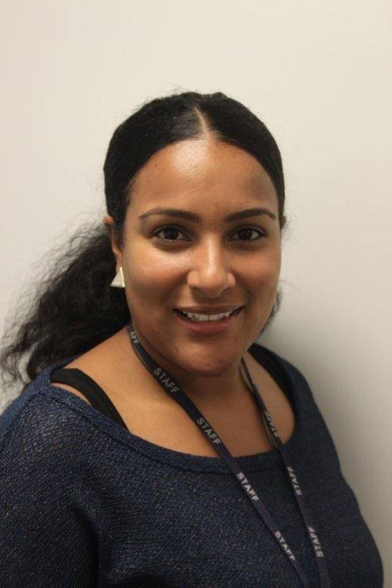

* My name is Nicita Sargeant and I will be the class teacher for Red class at the Heathfield Road site for the academic year 2020-2021.
* I have been at Mayfield School for the past six years, I have worked with students from different classes including SLD, PLMD and ASC. However, most of my experience is in ASC based classes.
* Red will be a class of eight students all diagnosed with autism, we will have a high staff ratio to meet the individual needs of each student.
* This year we are launching our new ‘Get Real’ curriculum; this curriculum will provide each student with personalised learning and the skills to become as independent as possible. The students will be taught through a workstation approach which aims to provide them with structure and routine throughout the school day.

Please communicate with us to let us know how your child is and if there is anything we can help with.

Tel: 0121 809 2500

Hello