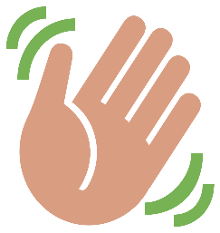
Hello Q3 Home learning 6th July 2020
This Photo by Unknown Author is licensed under CC BY-SA
Thank you to everyone who has worked hard this term.
I am so proud of you!

I am sad to say goodbye to you all as I am leaving Mayfield to work at a school closer to my home.
I have loved working with you this year, and I will keep in touch to check how you are getting on.

Goodbye to Akash from all your friends as you move to your new school too!
I hope you all have a lovely Summer.

I will miss you and I will remember you!
Keep working hard in your new class in September.
I‘m sorry I didn’t get to see you to say goodbye.
From Suse xx

Choose some of these activities to have a go at for home learning…
Online | Offline | Learning 4 Life
code.org https://code.org/hourofcode/overview  Complete the hour of code activities and practice your coding skills with Frozen, Minecraft and Star Wars coding programmes there is something for everyone.  ICT Games http://www.ictgames.com/  Website with lots of English and Maths games to support home learning  https://www.dkfindout.com/uk/  find out interesting information  BBC Super Movers https://www.bbc.co.uk/teach/supermovers  Active learning videos to covering Maths and Literacy practice your times table knowledge and grammar and punctuation understanding.  Switch Zoo  Watch, listen and play games to learn about a variety of animals and their habitats https://www.switchzoo.com/  www.bbc.co.uk/newsround  Find out what’s happening in the news.  https://education.theiet.org/key-stage-1-2-3-and-4-free-stem-resources/home-learning-resources-key-stage-1-and-2/  Free technology and engineering activities | 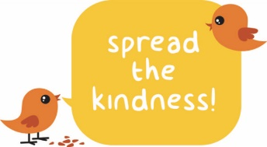  Think of 3 kind things you will do this week.  This Photo by Unknown Author is licensed under CC BY-SA  Ask people in your family what they are grateful for. Think about what makes you feel thankful too.  Draw a map of the streets around your home.  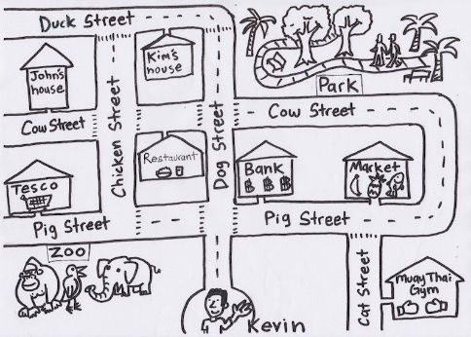  Fill an empty washing up bottle with water and practise writing spelling words on the ground.  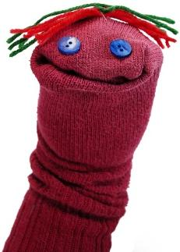  Design and make your own puppet. You could use a wooden spoon, a paper bag or even an old sock. You might make a few and put on a show!  Make a fruit salad.  Design a video game. Draw a story board to describe what happens. | For those students who wear glasses and/ or hearing aids, practice cleaning these every day independently. Ask an adult to check if you have done a good job.  Make a list of ways to care for your hair and skin.

