Independent Living Symbol Resources – LO1-4
LO: To identify a recipe for a well balanced healthy meal
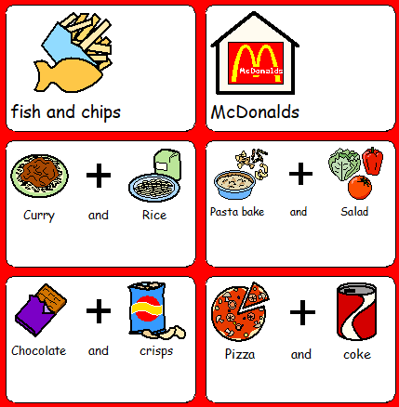

LO: To suggest at least one way to reduce the cost of the meal
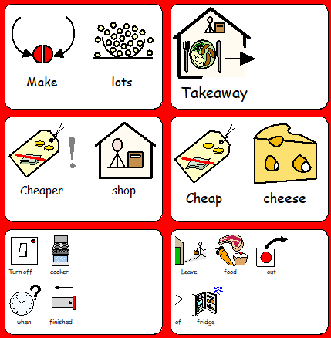

LO: To suggest at least one way to increase the number of fruit and vegetables in this meal
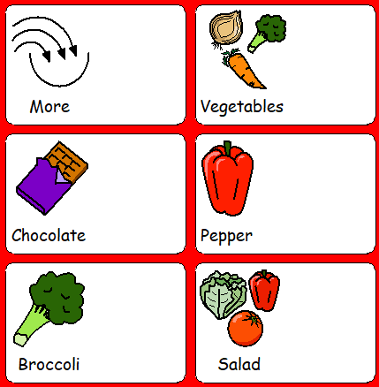

LO: To work in a safe and hygienic way
