WQ2- Home Learning (Noah’s Ark)
Our topic is ‘The Great Outdoors ’ this term. Here is a list of tasks to use for three lessons each day following the timetable below, if you feel that some structure to the day will help. Cut each lesson paper strip and place on top of the grid. English & Maths is the same every day. Topic is slightly different; you will need to cut out the correct lesson and ‘work’ symbols. Cover up each part of the lesson when you have completed it. Enjoy your learning together, be creative and have lots of fun! Please keep your work and take photos. We will be in touch soon about how you can upload and send us your work and pictures…Harder tasks in green!
Day | English | Maths | Topic
1. | - Practise your phonics with Jack Hartman  https://www.youtube.com/watch?v=59u6KaluscI  - Read the book ‘Noah’s Ark’ if you have it or use Noah’s Ark powerpoint.  - Talk about what happens in the story.  - Cut out animals, stick them onto the ark and label with the name (word/symbol).  - Take a photo and send to us!  Re-tell/re-write the story but think of your own pairs of interesting animals. Do a factfile on your favourite animal. | - Sing/act out ‘The animals went in 2 by 2’ using teddies or play figures  - Use a pack of cards; turn over cards, every time a 2 is picked find 2 items which are the same (identical).  - Count pairs of socks/shoes in 2s. See how far you can get!  Make an 100 grid, write numbers from 1-100 & then colour each square in the 2x table. Write out the 2x table and recognise 4x2=8 is the same as 2x4=8. | Do some Joe Wicks workouts or other exercise inside or outside which you enjoy!  Take a photo!
2. | - Use play dough to make the letter shapes with phonics song  https://www.youtube.com/watch?v=vb03r48XIuA  - Use the story posters to retell the story together.  - Cut out the stick puppets and use Sellotape to stick onto pencils/pens to act out the story.  - Take a photo and send to us!  Practise spelling year1/2/3 common exception words in sentences (see twinkl). | - Count in 2’s with Jack Hartmann  https://www.youtube.com/watch?v=OCxvNtrcDIs  - Put pictures of pairs of shoes by counting in 2s.  - Using an A4 sheet & Sellotape go outside; collect 2 of each objects you find & stick onto paper (eg 2 identical or similar leaves, sticks, flowers etc). See how many you can count in 2’s.  Practise 5x, 10x and 3x tables. Draw 100 grids like yesterday and complete for these timestables. | Make a rainbow cake with adult support! Or decorate biscuits with icing sugar & coloured smarties for the less brave!  www.bbcgoodfood.com
3. | - Revise letter sounds using Jolly Phonics  https://www.youtube.com/watch?v=26uXtUYssuo  - Use the story mat to talk about the animals in the story.  - Explore outside and find stones to make the story. Stick pictures onto stones.  - Take a photo of your work and send it to us  Instead of using pictures you could draw/colour your own stones with felt pens to retell story. | - Choose a 2D shape song from youtube  - Watch ‘The Book of shapes’ what is a semi circle? Semi means half.  https://www.youtube.com/watch?v=_Vk2N2GvONs  - Scavenger hunt for lots of things with a circular base that you could draw around. Draw and cut circle shapes out on paper. How could you make a semi-circle? Fold in half to make lots of semi-circles.  Cut out other shapes and see if they are symmetrical. Can you fold them in half exactly? | Make a kite using paper, crayons, string, scissors, stapler  Youtube Howcast.com  Enjoy flying it!
4. | - Sing ‘I can sing a rainbow’ with Mr Tumble  https://www.youtube.com/watch?v=yLpEGM34Fic  - Remember what happens in the story by watching song ‘The animals went in 2 by 2’.  - Colour the rainbow using the correct colours and identify the symbols.  - Take a photo of your work and send to us!  Create a rainbow as big as you want using paint, chalk, other art media & write colour names. | - Choose a 2D shape song from youtube  - Use things you can find at home to make outlines of shapes eg pencils to make a square, string to make a circle etc. Can you make a square, circle, rectangle & triangle? Have a race to see who is the quickest!  - Draw & cut a large circle, fold & cut in half. Make a rainbow shape.  Can you make a kite, parallelogram and oval? | Make a rainbow circle with skittle sweets (use plate, water or milk).  Watch carefully what happens!
5. | - Sing along and sway to ‘Somewhere over the rainbow’  https://www.youtube.com/watch?v=PSZxmZmBfnU  - Talk about the kindness of NHS workers. How can I be kind? How can I describe myself?  - Think of your own words to describe yourself and write/stick them onto the colours of your rainbow.  - Write sentences about yourself…’I am…because…’ or tell your family what you are like using signing. | - Choose a number song from you tube  - Go outside and using a container of water and a paint brush or chalk, draw 2D shapes on outside walls/on ground.  - Find things inside or outside which have straight edges and/or curved edges. Put them into groups. What kind of edges does a semi-circle have?  Don’t forget to take your photos and send to us! | Choose an activity to do together with your family which you enjoy!  Colour an NHS rainbow & talk about the brave work of medical and social care workers.  Write a letter to thank the NHS or to a keyworker you know.
Helpful websites:
- www.sumdog.com/user/sign in (maths),
- www.activelearnprimary.co.uk (bug club login – reading)

Most resources (and more) for this week’s theme Noah’s Ark can be found at www.twinkl.co.uk. You can join for free!

My timetable What am I learning today?
English
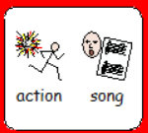 | 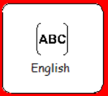 | 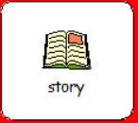 | 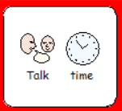 | 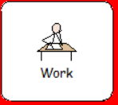 | 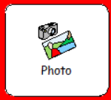
Maths
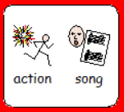 | 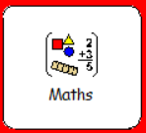 | 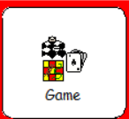 | 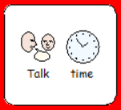 | 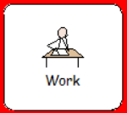 | 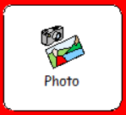
Topic (day 4)
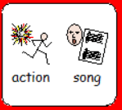 | 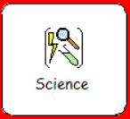 | 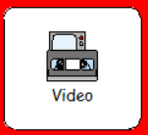 | 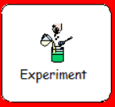 | 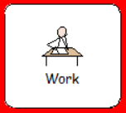 | 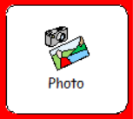

My Timetable What am I learning today?

