LO: Recognise how technology is used in the community (E2.2)

AC: Identify how technology is used in the local community (E2.2.1)

Task 1: Students will look at the pictures and choose which is technology in the community.
Extra challenge – Write down/draw any more you can think of

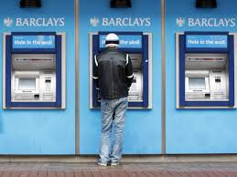 | 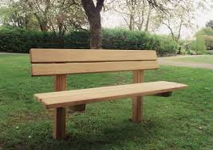
Task 2: Students will look at the 3 pieces of technology and will match the symbols that you would need
Extra challenge – Write down/draw any more you can think of
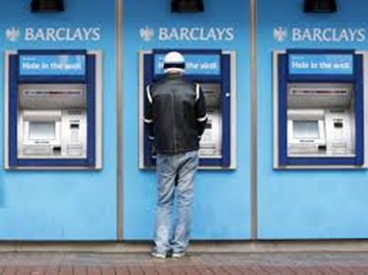 | 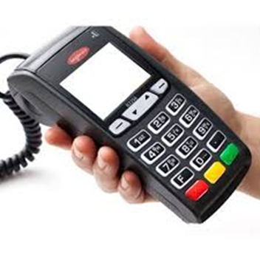

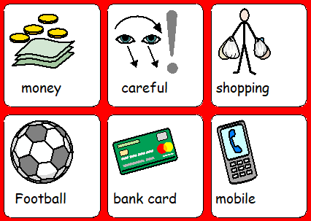

Task 3: Go out for a walk and find as much technology in the community that you can such as ATMs, card machines etc. Picture evidence of the students pointing out what they can see is required.
Extra Challenge – Use a piece of technology in the community

