WQ2- Home Learning (Superworm)
Our topic is ‘The Great Outdoors ’ this term. Here is a list of tasks to use for three lessons each day following the timetable below, if you feel that some structure to the day will help. Cut each lesson paper strip and place on top of the grid. English & Maths is the same every day. Topic is slightly different; you will need to cut out the correct lesson and ‘work’ symbols. Cover up each part of the lesson when you have completed it. Enjoy your learning together, be creative and have lots of fun! Please keep your work and take photos. We will be in touch soon about how you can upload and send us your work and pictures…Harder tasks in green!
Day | English | Maths | Topic
1. | - Practise your phonics with Jack Hartman  https://www.youtube.com/watch?v=59u6KaluscI  - Watch and read ‘Superworm’ together on youtube  https://www.youtube.com/watch?v=0keNDquvZEE  - Talk about all the things superworm can do (be a swing, train, skipping rope etc) & use a skipping rope or long piece of cord to act out.  - Practise pencil control using worm sheets or your finger in a tray of sand/flour. See how many letters/words you can write!  Practise spelling Yr 1, 2, 3, 4 common exception words in the tray. How many can you get right? | - Count in 2’s with Jack Hartmann  https://www.youtube.com/watch?v=OCxvNtrcDIs  - Play caterpillar ordering numbers game  https://www.topmarks.co.uk/ordering-and-sequencing/caterpillar-ordering  - Go on a minibeast hunt in the park/garden & see how many you can find! Count how many of each different bug you find. Use the checklist.  Complete a chart mapping where you have found the minibeast & make a tally of each kind | Do some Joe Wicks workouts or other exercise inside or outside which you enjoy!  Take a photo!
2. | - Use play dough to make the letter shapes with phonics song  https://www.youtube.com/watch?v=vb03r48XIuA  or practise spelling words with ict games  http://www.ictgames.com/mobilePage/lcwc/index.html  - Re-read Superworm, pausing video to see if you can remember what happens next. Can you remember the chant?  - Cut & stick minibeasts and write the initial sound or whole word if you can, listening for, saying/signing each sound  Complete differentiated reading activity about worms. | - Watch & sing ‘The minibeasts went in 2by2’ powerpoint  - Can you make the longest worm you possibly can with playdough or pipe cleaners or anything else you can think of- take a photo!  - Find lots of things in your home/outside that are super-long!  Practise butterfly times tables and extra challenges | Make a wormery or a habitat for a minibeast (see step by step guide)
3. | - Revise letter sounds using Jolly Phonics  https://www.youtube.com/watch?v=26uXtUYssuo  or practise spelling words with ict games  http://www.ictgames.com/mobilePage/lcwc/index.html  - Complete ‘What am I? minibeast powerpoint  - Find out about your favourite mini-beast, draw/print a picture, write some facts, learn something new & tell someone!  Read the fact cards about minibeasts and write a summary of new things you have learned. | - Choose a number song on youtube  - Play caterpillar ordering numbers game  https://www.topmarks.co.uk/ordering-and-sequencing/caterpillar-ordering  - Minibeast I spy count to 20  - Minibeasts multiplication mosaics | Get some plastic takeaway containers. Place mini plastic animals inside and fill with water. Freeze overnight. Then the next day have fun chipping away at/smashing the ice in a tray to free the animals  Take a photo!
4. | - Log onto Bug Club and read a story/practise phonics  - Can you find things in your home/outside that are super-strong? Take a photo!  - Go on a walk to see which birds you can spot. Have you seen a blackbird, like the one in the story? Talk about which birds you have seen.  Draw and write about a bird you have seen or a favourite bird. | - Watch & sing ‘The minibeasts went in 2by2’  - Talk about long and short  https://www.youtube.com/watch?v=ryIxBrO1bJY  - Order lengths of different worms (see sheet)  Complete a bird bar chart of birds you have seen. | Do the spaghetti worms experiment (see sheet)
5. | - Log onto Bug Club and read a story/practise phonics  - Talk about minibeasts and their habitats by researching online together  - Match minibeasts to their habitats  Write about how you made your wormery earlier in the week and what worms need in their habitat. | - Look at ‘Where is worm?’ powerpoint on twinkl using positional language  - Choose your favourite cuddly and take pictures of them in different places- on, in, behind etc  More minibeast mosaics!  Don’t forget to take your photos and send to us! | Choose an activity to do together with your family which you enjoy!  Use chalk to colour bricks/the ground for the NHS.
Helpful websites:
- www.sumdog.com/user/sign in (maths),
- www.activelearnprimary.co.uk (bug club login – reading)

Most resources (and more) for this week’s theme ‘Worms & Minibeasts’ can be found at www.twinkl.co.uk. You can join for free!

My timetable What am I learning today?
English
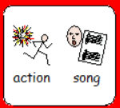 | 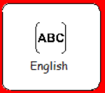 |  | 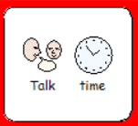 | 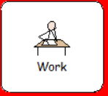
Maths
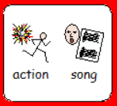 | 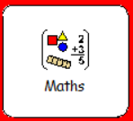 | 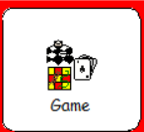 | 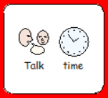 | 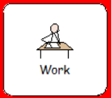
Topic (day 4)
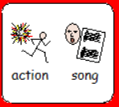 |  |  | 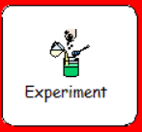 | 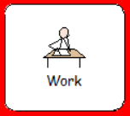

My Timetable What am I learning today?

