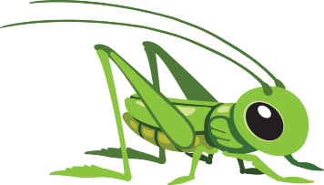
Week beginning 11th May 2020
This Photo by Unknown Author is licensed under CC BY-NC
Hello! Welcome to the Grasshoppers home learning page.
We hope you are well and staying safe. Thank you to the families that have completed the previous home learning activities set, it’s great to see the pictures on the SeeSaw app of you having fun and learning together at home.
Over the next week we would like you to focus on the following objectives for Maths. Please email me the photographs taken of your child completing the tasks. These photographs can be taken on your mobile phones and attached through email to myself or shared through the SeeSaw app.
1) Go on a shape hunt around the house finding objects that are squares, rectangles, triangles and circles. Take a picture of what you find.
2) Make a shape picture using the different shapes cut from different coloured papers or pages from an old magazine.
There are other activities set on the SeeSaw app including adding ‘Crazy Hair’ Please have a go.
COMPETITION
Make a minibeast from things you can find around your home, old drink bottles, lids, rolls etc Take a photograph and email to
me or post on the
Seesaw app. Prizes
for the best
minibeast.

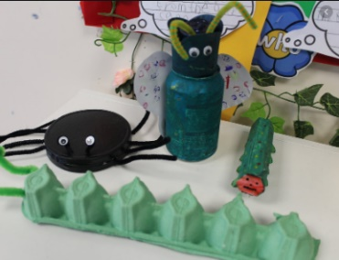
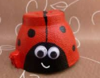

Try to take at least 1 photo of your child completing each activity and let us know how they got on with the task.
Should you have any questions about the activities then please send an email with your questions to grasshoppers@mayfield.bham.sch.uk
Many thanks
Angela

