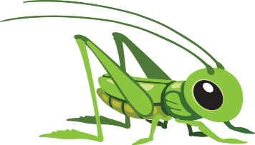
Week beginning 1st June 2020
This Photo by Unknown Author is licensed under CC BY-NC
Hello! Welcome to the Grasshoppers home learning page.
We hope you are well and staying safe. Thank you to the families that have completed the previous home learning activities set, it’s great to see the pictures on the SeeSaw app of you having fun and learning together at home.
Over the next week we would like you to focus on the following objectives for Maths. Please email me the photographs taken of your child completing the tasks. These photographs can be taken on your mobile phones and attached through email to myself or shared through the SeeSaw app.
1) Go on a number hunt. What numbers does your child recognise? on the front door, in a magazine, on a car number plate, anywhere they might see a number
2) Count objects that can be moved and those that cannot with 1 to 1 correspondence. This might mean putting objects in a straight line to count and supporting their finger to point as they count.
There are other activities set on the SeeSaw app including ‘making a insect from things in the garden’ or going on an outdoor scavenger hunt. Please have a go.
Please remember the competition which is still running. I can’t wait to see the minibeasts
COMPETITION
Make a minibeast from things you can find around your home, old drink bottles, lids, rolls etc Take a photograph and email to
me or post on the
Seesaw app. Prizes
for the best
minibeast.

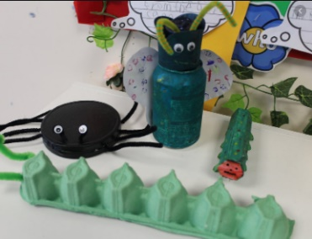
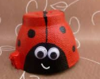

Please try and complete 2/3 activities over the week and either post on Seesaw or send me photographs. Most people on now on Seesaw so please let me know if you still need help to get on please. Should you have any questions about the activities then please send an email with your questions to grasshoppers@mayfield.bham.sch.uk
Many thanks
Angela

