Welcome to your new class for 2020-2021
Hello, and welcome to your new class for 2020-2021. My name is James Shore and I am going to be your teacher next year. I have been at Mayfield School since September 2019 and I have taught at lot of you last year, and know you all from doing my gate duties.
Your Teaching Assistants will be Lorna and Julie, all of our photos are below so you can get to know who we are before September.
We are going to have lots of fun next year and learn lots of new things. We will have communication books so we can write to parents / guardians to let you know what exciting things we have been up to.

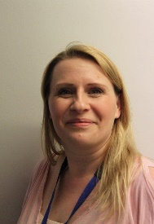
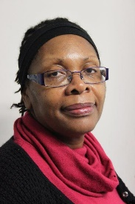

Julie James Lorna
Next year we are going to be doing lots of activities around independent living and getting us ready for Sixth Form. To help you get ready over the holiday please try to take part in as many household tasks as possible, hoovering, cleaning, using the dishwasher, doing the gardening – as many as you can try.
Please check the school website for more activities you can take part in over the holidays linked to our curriculum in September.
If you have any questions please do not hesitate to get in contact with me j.shore@mayfield.bham.sch.uk

We are really looking forward to welcoming you in September.
James, Julie and Lorna

