All about me!

In order for us to get to know your child better we would be grateful if you could help your child to complete this sheet.

Things that make me happy:

Foods I like to eat:

This is me!

Add a picture here.

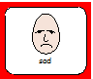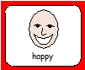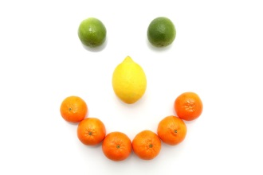

Foods I don’t like:

People who live with me:

Things that make me sad::