LO: To show knowledge of the five different food groups needed for a balanced diet
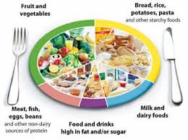

Students to match symbols to the image of the plate. Discuss each with an adult and try and think of other examples for each group. Write these down. If no printer then students can draw the image of the plate (with help).

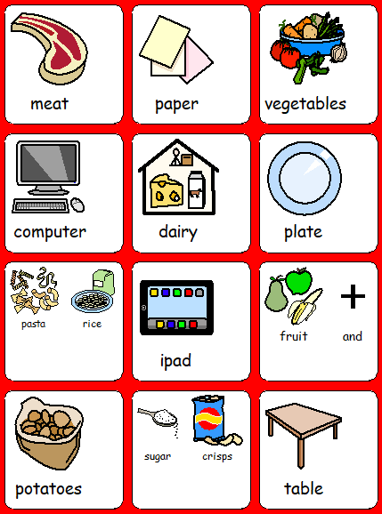

LO: To create a healthy balanced main meal within a £1.20 per head budget.

Use the menus provided to cook the meal. Students to help make the shopping list (may not be able to go shopping). Take pictures of making the meal, any counting of money and making the shopping list.

