LO: Recognise how technology is used in the home (E2.1)

AC: Demonstrate safe practices when using technology in the home (E2.1.2)

Task 1: Students are going to use 3 pieces of technology safely. Take pictures of the students following the directions to use it safely, remember practice makes perfect!
Extra challenge – Write or draw your own directions to use it safely

Microwave:
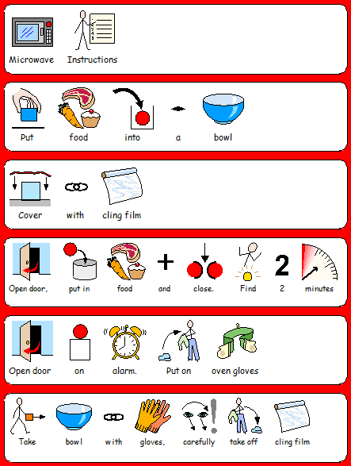
Toaster:

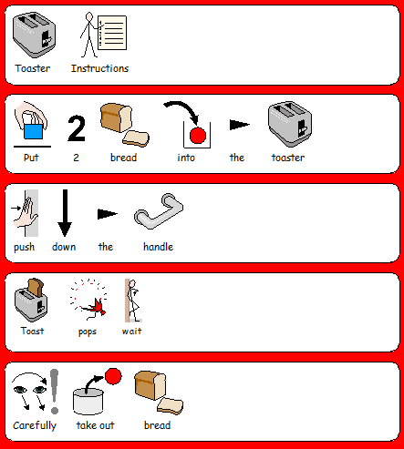

Vacuum Cleaner:
