Stories on YouTube
The very hungry caterpillar: https://www.youtube.com/watch?v=75NQK-Sm1YY
The gingerbread man: https://www.youtube.com/watch?v=pckuS--UlV4
We are going on bear hunt: https://www.youtube.com/watch?v=Waoa3iG3bZ4
Dear zoo song: https://www.youtube.com/watch?v=KsHXDPxozTk
PE sessions and actions songs on YouTube
https://www.youtube.com/watch?v=KAT5NiWHFIU
https://www.youtube.com/watch?v=RLOOOjGAM1s
https://www.youtube.com/watch?v=388Q44ReOWE
https://www.youtube.com/watch?v=dUXk8Nc5qQ8
https://www.youtube.com/watch?v=hzo9me2fdzg
https://www.youtube.com/watch?v=2UcZWXvgMZE
https://www.bbc.co.uk/teach/supermovers
Useful pages on face book
https://www.facebook.com/SensationalCreations/
https://inclusiveteach.com/2020/03/20/150-sensory-learning-ideas/?fbclid=IwAR38rmADnGpnORv44owoIahD7oKoezLEoeAcUqysADtrVUDhO20z22ngyd0

Other websites
https://www.tts-group.co.uk/home+learning+activities.html?utm_source=facebook&utm_medium=wallpost&utm_campaign=TTSparentpackpost&utm_content=nowlive
https://www.firstdiscoverers.co.uk/sensory-activities-children-autism/
Educational websites
https://www.abcmouse.com/landing/sem:goog:uk?utm_campaignid=6443481067&utm_adgroupid=77348128739&utm_adextensionid=&utm_targetid=kwd-317582711955&utm_matchtype=e&utm_network=g&utm_device=c&utm_devicemodel=&utm_creativeid=376589111463&utm_placement=&utm_adposition=&utm_geo=UK&gclid=CjwKCAjwguzzBRBiEiwAgU0FT4llQbIM3-1gqPxBogSA_46o9pX3Vf233IrLqqMQE-ZyU3LaXqc0JxoCCLMQAvD_BwE
https://www.sesamestreet.org/
https://www.verywellfamily.com/teaching-your-preschooler-how-to-count-2162482
https://www.natgeokids.com/uk/play-and-win/games/cats-memory-game/
Educational apps
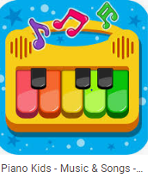Music kids

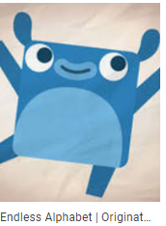Endless alphabet
Happy colour
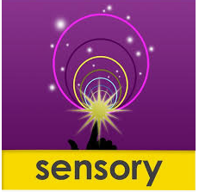Just touch
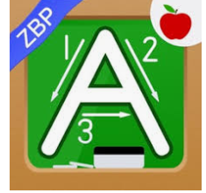ABCs kids preschool
Math Bingo
Draw Glow a number
Animals sounds for kids
Animals puzzle game
ABC PreSchool Kids Tracing & Phonics Learning Game

