Home Activity Pack

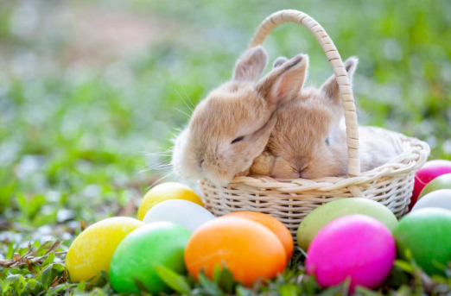

A range of possible activities for you and your child to access and enjoy together.

Contents
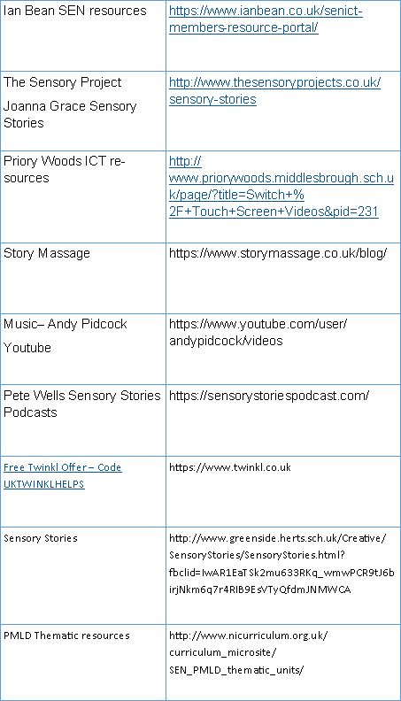

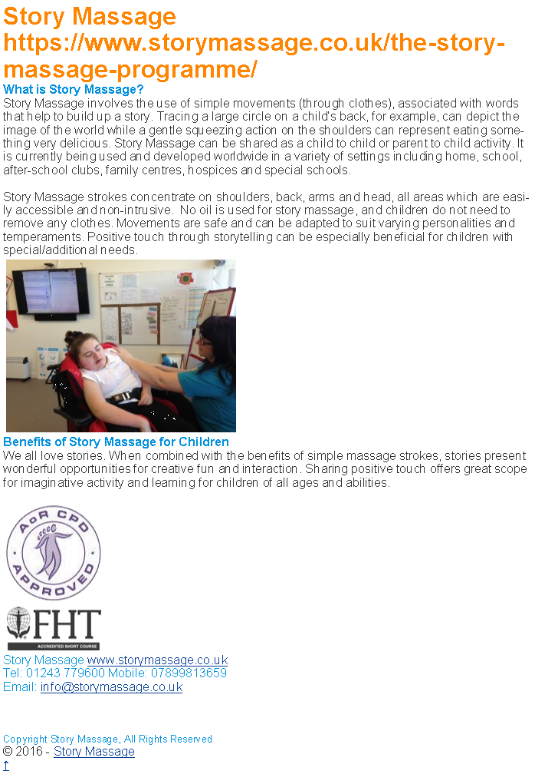

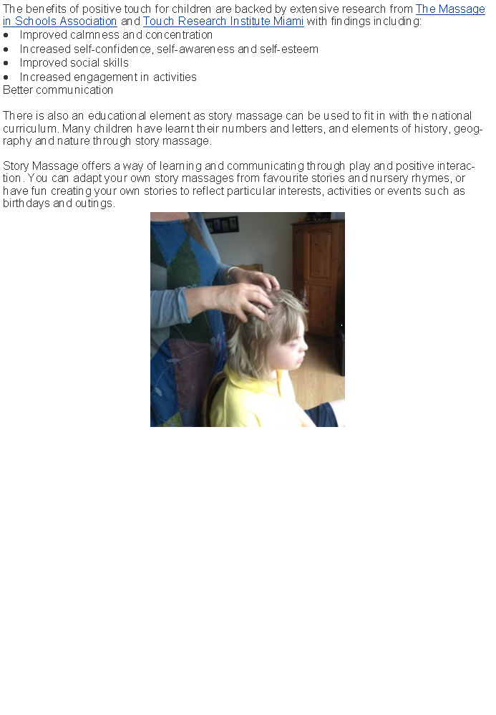

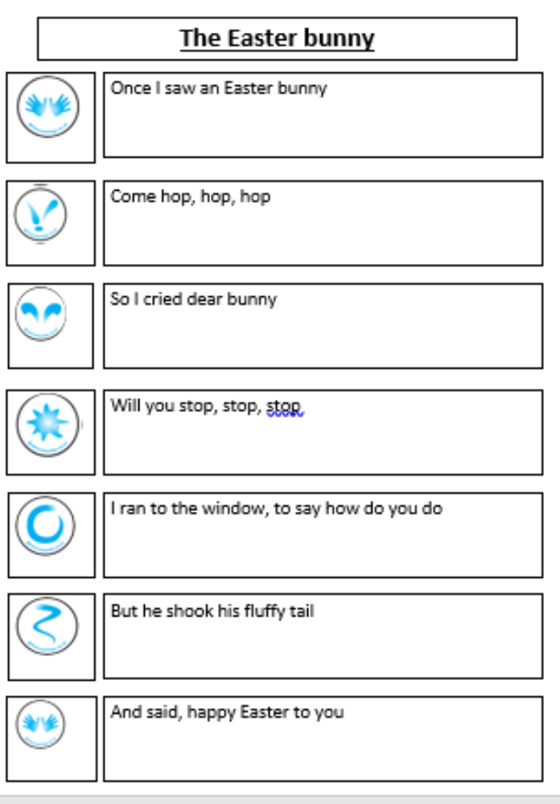
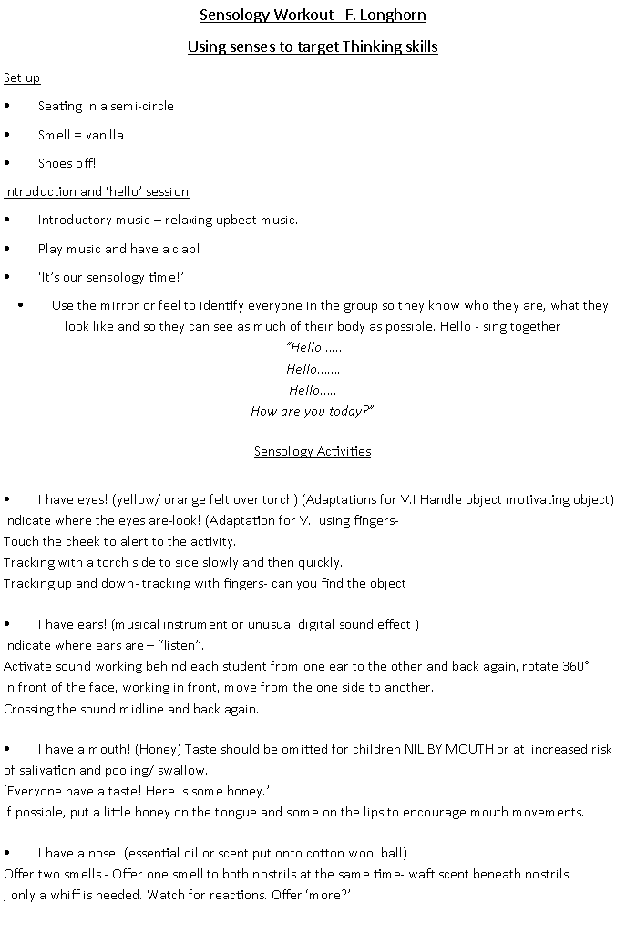
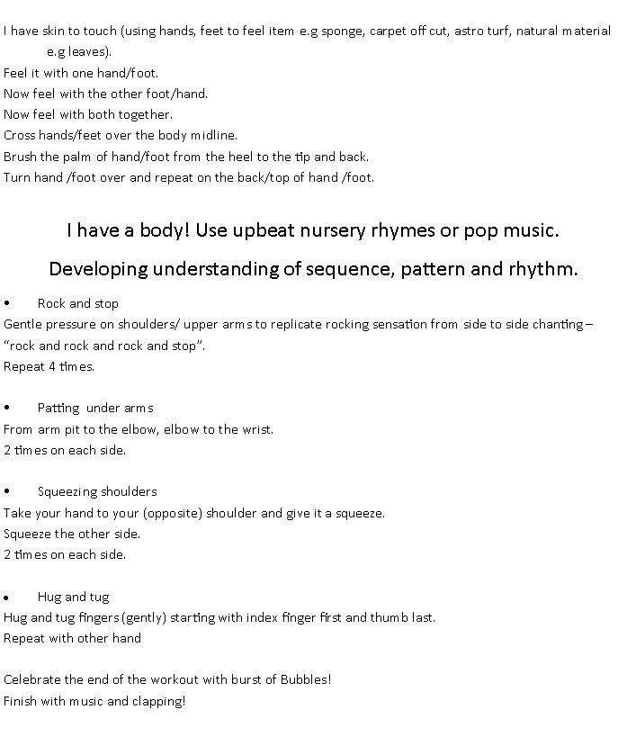

Dosbarth 3 Comes Dancing
Dance Massage

Area of Learning & Experience: Health & Wellbeing
Links to : LLC, MD, Sci & Tech, Expressive Arts
Resources: essential oil– lavender
Music from youtube—BBC-Strictly Come dancing Intro, Waltz, Tango, jive, Paso Doble, Quickstep, Cha cha, Foxtrot, Rumba, Samba. Scarves
Objective: To look for intent to communicate ‘more’; to reject activity.
Ensure you ask the young person’s permission to massage before session.

Environment: Dim lights, activate sensory lights/mirror ball /iPad, and remove shoes.

Activity marker: Ribbon for dancing
Intro: Strictly Come Dancing Intro video | Pat all over the student’s body (arms, legs, back and shoulders0 to the beat of the music to set the scene.
Waltz video clip & music | Choose 3 key points on the body e.g shoulder, elbow and hand. Gently squeeze each in turn, in time to the music 1,2,31,2,3…..  Alternatively massage the shoulders in waltz time, applying most pressure on the 1st beat, with lighter pressure on counts 2 and 3.
Tango video clip & music | Support the student to hold their leg out in front of them, massage briskly and firmly up and down the leg from ankle tio knee in time with music. Swap legs
Jive video clip and music | Using your fingertips, ‘pitter-patter’ up the student’s arm and legs, using light jumpy movements in time with the music.
5. Paso Doble video clip and music | Use a scarf to run up the student’s arms and legs in time to the music.
Quickstep video & music. | Support the student to hold one arm out straight by performing a continuous stroke from under the arm, near to the armpit to the wrist. Extend this to the fingertips before repeating.
Cha cha video & music | Massage up the entire arm using twisting movements over and under the arm in time with the music.
Foxtrot music & video. | Massage the student’s feet in time to the music, paying particular attention to the heels and toes.
Rumba music & video | Massage down each of the student’s arms slowly and smoothly from the middle of the shoulders down the wrists.
Samba music & video. | Lightly and briskly, pat the student’s hand and soles of their feet in time to the music. Really have fun with this one, as a finale to the massage.
Plenary: Praise all pupils in turn, review the session with the whole group, identify which massage pupils responded to more and if possible demonstrate to the class. When all young people have showcased sing ‘Brilliant blue’ or ‘On the way orange’ songs to each young person.

Hand Massage
