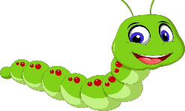
Week beginning 15th June 2020
This Photo by Unknown Author is licensed under CC BY-NC
Hello! Welcome to the Caterpillars home learning page.
We hope you are well and staying safe. Thank you to the families that have completed the previous home learning activities set, it’s great to see the pictures on the SeeSaw app of you having fun and learning together at home.
Over the next week we would like you to focus on the following objectives for Maths. Please take photographs of your child and post them on the Seesaw website
1) Recognising shapes and colouring them in
2)Finding shapes in nature as outdoor scavenger hunt.
There are other activities set on the SeeSaw app including a heart map, what makes your heart full, get the children to draw pictures in the heart till it is full.
Remember the competition I’d love to see how your sunflowers are growing, you may need to put it into a bigger pot now or put it into the garden
COMPETITION
Who can grow the biggest sunflower?
Now you have planted your seed look after it and watch it grow. There will be a prize for the biggest sunflower, so keep watching it and send me photographs as it grows.

Please try to do at least 2/3 activities with your child over the week and post on Seesaw Should you have any questions about the activities then please send an email with your questions to caterpillars@mayfield.bham.sch.uk
Many thanks
Angela

